|  |  |
| --- | --- |
|  | **Web Designing Assignment**  **Module (Bootstrap Basic & Advanced) – 6** |

1. **What are the advantages of Bootstrap?**

**Ans:** It is open-source, making it an accessible choice for developers aiming to create responsive and visually appealing websites. Bootstrap also provides a collection of tools, styles, and components to streamline the process of [web development](https://www.geeksforgeeks.org/web-development/).

* **Speedy Development:** Bootstrap’s ready-made components accelerate development, enabling faster project completion.
* **Responsive by Design:** The built-in grid system ensures websites adapt seamlessly to diverse screen sizes and devices.
* **Consistent UI Elements:** Bootstrap maintains a uniform look and feel across various elements, ensuring a cohesive user experience.
* **Cross-Browser Compatibility:** Bootstrap handles browser differences, minimizing the need for extensive testing and ensuring a consistent user experience.
* **Flexible Customization:** Customizable themes, variables, and mixins provide flexibility to match specific project requirements and branding.
* **Community Support:** Being open-source, Bootstrap benefits from a robust community, offering resources, documentation, and third-party plugins.

1. **What is a Bootstrap Container, and how does it work?**

**Ans:** Bootstrap Containers are the most basic layout element in Bootstrap. Bootstrap Containers are very essential and basic building blocks of bootstrap that wrap a page’s content. It’s responsible for setting and aligning content within it according to viewport or given device. Containers are defined within the container class (.container). In other words, we can say that containers are established the width for the layout to give the content. Elements and content are added within the container.

Containers are used for many purposes such as –

* It requires use with the default grid system.
* To establish width for the layout to give web content.
* To provide responsive fixed behaviour of any web project.
* To sets the content margin dealing with the responsive behaviour of your layout.

Bootstrap has the default class or predefined class is “.container” & “.container-fluid” class for layout. Containers are used to contain, pad, and (sometimes) center the content within them. While containers can be nested, most layouts do not require a nested container.

Basically, there are three types of container classes available in bootstrap:

1. Default-Container(container)
2. Responsive-Container (along with sm, md, lg, xl, xxl)
3. Fluid-Container(container-fluid)
4. **What are the default Bootstrap text settings?**

**Ans:** Bootstrap Default Settings Bootstrap uses a default **font-size of 16px**, and its **line-height is 1.5**. The default font-family is "Helvetica Neue", Helvetica, Arial, sans-serif. In addition, all <p> elements have margin-top: 0 and margin-bottom: 1rem (16px by default).

1. **What do you know about the Bootstrap Grid System?**

**Ans: Grid System:** Bootstrap Grid System allows up to 12 columns across the page. You can use each of them individually or merge them together for wider columns. You can use all combinations of values summing up to 12. You can use 12 columns each of width 1, or use 4 columns each of width 3 or any other combination.

[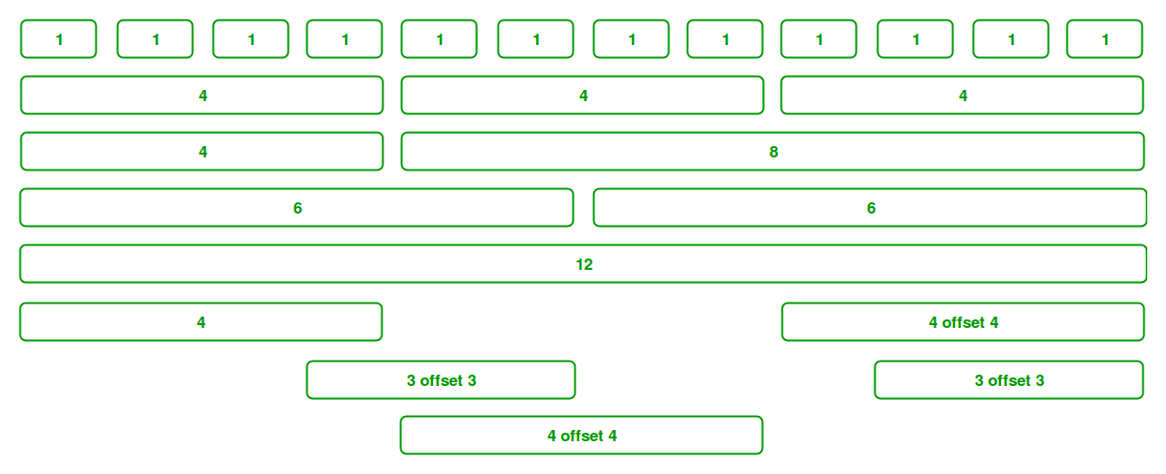](https://media.geeksforgeeks.org/wp-content/uploads/Bootstrap-part-2.png)

1. **What is the difference between Bootstrap 4 and Bootstrap 5**

**Ans:**

|  |  |  |
| --- | --- | --- |
| **BASIS OF** | **BOOTSTRAP 4** | **BOOTSTRAP 5** |
| **Grid System** | It has 5 tier (xs, sm, md, lg, xl). | It has 6 tier (xs, sm, md, lg, xl, xxl). |
| **Color** | It has limited colors. | Extra colors added with the looks, A card improved color palette. there are various shades available to choose. |
| **Jquery** | It has jquery and all related plugins. | Jquery is removed and switched to vanilla JS with some working plugins |
| **Internet Explorer** | Bootstrap 4 supports both IE 10 and 11. | Bootstrap 5 doesn’t support IE 10 and 11. |
| **Form elements** | Radio buttons, checkboxes have different look in different OS and browsers. The form uses whatever default browsers provide. | The look of form elements will not change, on different OS or browser. The forms can be customized and form controls can be added, they would not depend on browser. |
| **Utilities API** | We cannot modify utilities in bootstrap 4 | Bootstrap 5 gave freedom to modify and also create our own utility |
| **Gutter** | We use .glutter with fontsize in px | We use .g* with fontsize in rem |
| **Vertical Classes** | Columns can be positioned relative | Columns cannot be positioned relative |
| **Bootstrap Icons** | Bootstrap 4 doesn’t have its own SVG icons, we have to use font-awesome for icons. | Bootstrap 5 have its own SVG icons |
| **Jumbotron** | It supports. | It doesn’t support jumbotron. |
| **Card deck** | The card deck is used to create a set of cards with equal width and height. | Card deck class in removed in bootstrap |
| **Navbar** | We have inline-block property and we will get white dropdown as default for dropdown-menu-dark class. | Inline-block property is removed and we will get black dropdown as default for dropdown-menu-dark class. |
| **Static Site Generator** | Bootstrap 4 uses Jekyll software. | Bootstrap 5 uses Hugo software as it is fast static site generator. |

|  |  |  |
| --- | --- | --- |
| **BASIS OF** | **BOOTSTRAP 4** | **BOOTSTRAP 5** |
| **flexbox grid** | this makes easier to implement vertical designs, and the columns and rows can easily be implemented. the classes justify-center-content can directly be used to align according to the requirement. | advanced grid system is made available , also columns don’t have relative positions. |
| **RTL Support** | It does not enable RTL(Right to Left) switching. | It enables RTL(Right to Left) switching. |
| **Off canvas Component** | It does not support Off canvas Component. | It supports Off canvas Component(that is it is available now). |

1. **What is a Button Group, and what is the class for a basic Button Group?**

**Ans:** “Button Groups” in [Bootstrap](https://www.geeksforgeeks.org/bootstrap/) is a class of name “btn-group” which is used to create a series of buttons in groups (without spaces) vertically or horizontally.

**Syntax:**This is the basic syntax of the button group class where each button has its own class of “btn”**.**

**<div class="btn-group">**

**<button type="button" class="btn">Click</button>**

**</div>**

Buttons have a default border-radius on the first and last buttons of the group.

**Adding Styles on Buttons:**[Bootstrap](https://www.geeksforgeeks.org/bootstrap/) allows you to add styles to your buttons using the following classes:

* .btn-default
* .btn-primary
* .btn-success
* .btn-info
* .btn-warning
* .btn-danger
* .btn-link

1. **How can you use Bootstrap to make thumbnails?**

**Ans:** [Bootstrap](https://www.geeksforgeeks.org/bootstrap-tutorials/)helps web developers to create thumbnails that are used to show linked images in grids with the pre-defined classes which help to reduce codes length. Thumbnails are created to provide a quick preview of images with small images.

**Thumbnail Image:**A thumbnail is a small image that represents a larger image. Bootstrap has an easy way to do this with thumbnails. Bootstrap’s .thumbnail class is used to show linked images in grids ([grid system](https://www.geeksforgeeks.org/bootstrap-4-grid-system/)), a thumbnail is created using class .thumbnail within the element [<a>](https://www.geeksforgeeks.org/html-a-tag/#:~:text=HTML%20Tag,-Difficulty%20Level%20%3A%20Basic&text=The%20tag%20(anchor,as%20its%20%E2%80%9Chref%E2%80%9D%20value.).  The class .col-sm-* and .col-md-* (where * represent number), it is used to create grids of the images.

**Step by step guide for the implementation:**

**Step 1:** Include Bootstrap and jQuery CDN into the <head> tag before all other stylesheets to load our CSS.

<link rel=”stylesheet” href=”http://maxcdn.bootstrapcdn.com/bootstrap/3.3.6/css/bootstrap.min.css”>   
<script src=”https://ajax.googleapis.com/ajax/libs/jquery/1.12.0/jquery.min.js”></script>   
<script src=”http://maxcdn.bootstrapcdn.com/bootstrap/3.3.6/js/bootstrap.min.js”></script>

**Step 2:** Add [<div>](https://www.geeksforgeeks.org/div-tag-html/#:~:text=The%20div%20tag%20is%20used,%2C%20navigation%20bar%2C%20etc).&text=It%20is%20used%20to%20the,can%20be%20applied%20to%20them.) tag in the HTML body with class row. In that <div> create four div sections to create four images.

**Step 3:** Add “col-sm-6” and “col-md-3” to four div sections which creates webpage responsive.

**Step 4:** Add [<a>](https://www.geeksforgeeks.org/html-a-tag/) tag with class value thumbnail to define the link of the image in the next line.

<a href="#" class="thumbnail">

1. **In Bootstrap 4, what is flexbox?**

**Ans:** In [Bootstrap 4](https://www.javatpoint.com/bootstrap-4), flex box is used to control the layout and alignment specification of Bootstrap 4 components. This box makes it easier to design flexible responsive layout structures without using float or positioning attributes.

**Syntax**:

<div class="d-flex p-2"></div>

The d-inline-flex class is used to create an inline flexbox container

**Syntax**:

<div class="d-inline-flex p-2"></div>

.d-flex and .d-inline-flex can be used for all breakpoints(sm, md, lg, xl) like .d-sm-flex, .d-sm-inline-flex, etc.

**Syntax**:

<div class="d-sm-flex p-2"></div>  
<div class="d-sm-inline-flex p-2"></div>

1. **How can one create an alert in Bootstrap?**

**Ans:** In [Bootstrap](https://www.geeksforgeeks.org/bootstrap/), alerts are the most important component to provide customized feedback messages and warnings. Using this alert component, we can properly deliver the information warnings, success messages, and errors to the user.

**Syntax**:

<div class="alert alert-success" role="alert"></div>

* We will use the. alert class along with the contextual classes that are used to display the alert message in the application.
* The alert classes like. alert-success ,.alert-info, .alert-warning, .alert-danger, .alert-primary, .alert-secondary, .alert-light, and .alert-dark are been used to represent the alert message with different behaviour.
* We will generate the dynamic alert message when the user clicks on the button.

1. **What is a bootstrap card and how would you create one?**

**Ans:** A card is a flexible and extensible content container. It includes options for headers and footers, a wide variety of content, contextual background colors, and powerful display options.

It replaces the use of panels, wells and thumbnails. All of it can be used in a single container called card.

**Basic Card:**The building block of a card is the **card-body**within the parent class **card**.

**Header and Footer:**The **card-header** provides a header to the cards and **card-footer** provides a footer to the cards.

**Card Title and Links:**The **card-title** is used to give a title to the card and **card-link** is used to provide link to the card if required in it.

**Card Images:**The images to the card are inserted with **card-img-top** and with **card-img-bottom**with the help of these two and **img** tag is used with it to input the image.

**Image Overlays:**In this we have to just use an extra class call the **card-img-overlay** in the same line of code which you have used for card images.